## Part 1: Create a design | 1 week

## Brainstorming:

1. One fixed magnet and movable magnet

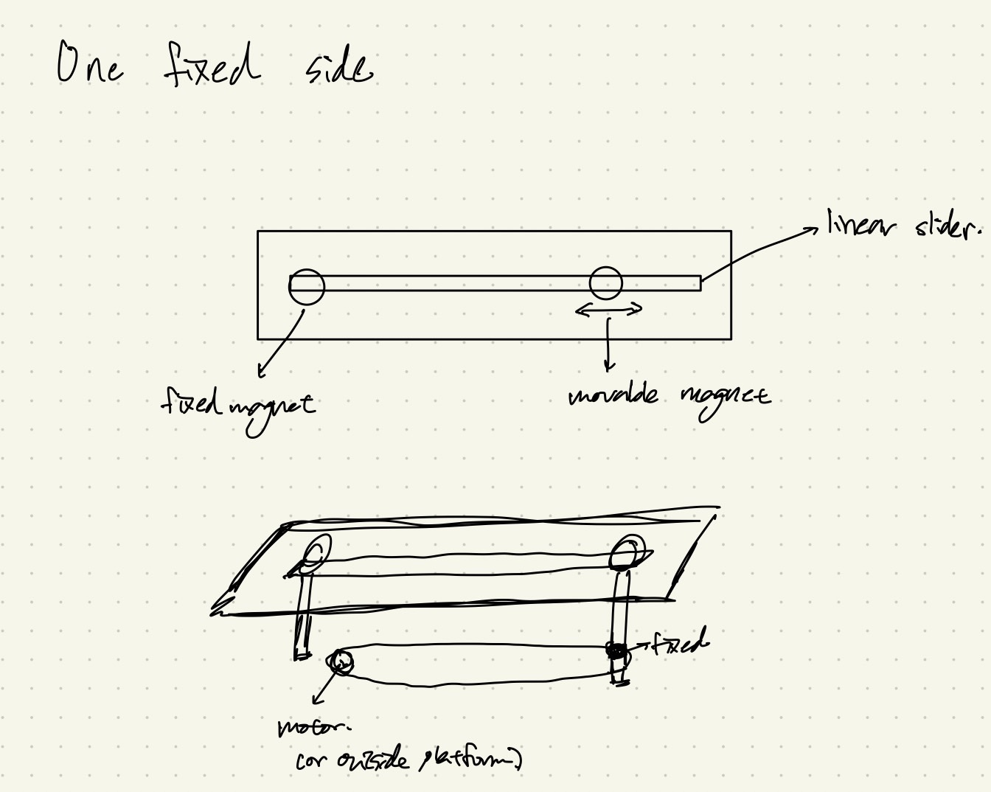

Description:

This design includes one fixed magnet and one movable magnet which is similar to while the user fixes the thumb and moves the pointer finger. The transmission in this design is a timing belt and actuated by a motor(step or DC motor). Also, we fixed the magnet in linear direction by using a linear slider.

2. Two movable magnet

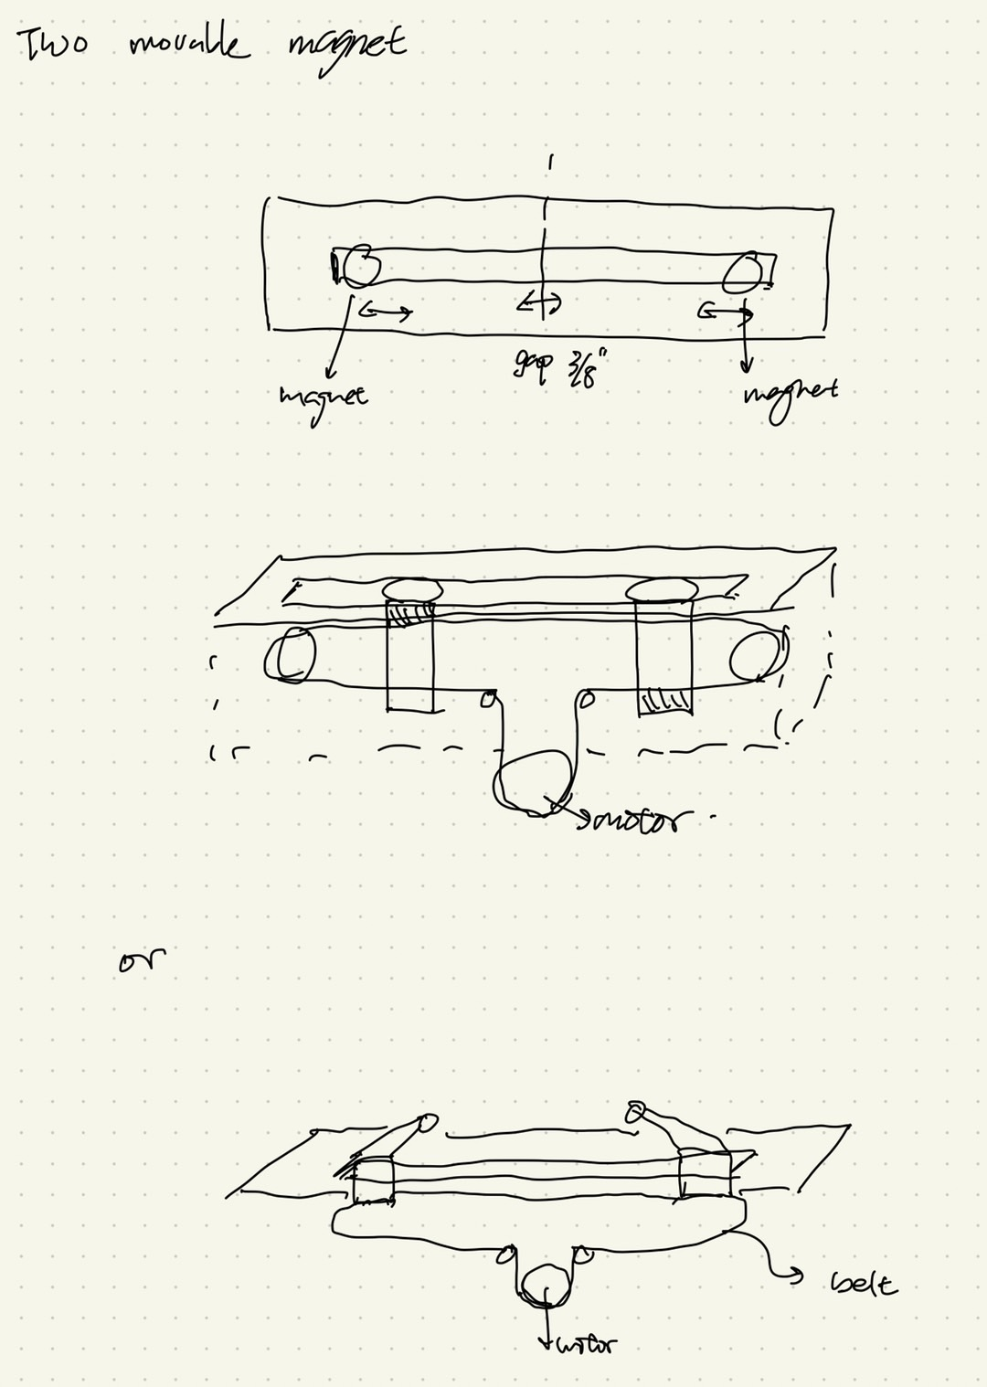

Description:

In this design, we use two magnets which connect to the timing belt and fix one side of the magnet on the belt which is like the user zooming in or zooming out the screen. For the first one above, there will be a gap between two magnets in the size of the motor. We can improve the mechanism to the second sketch which can close the gap of both magnets to ⅜ inches. Also, we fixed the magnet in linear direction by using a linear slider.

3. Spiral structure for two movable magnet

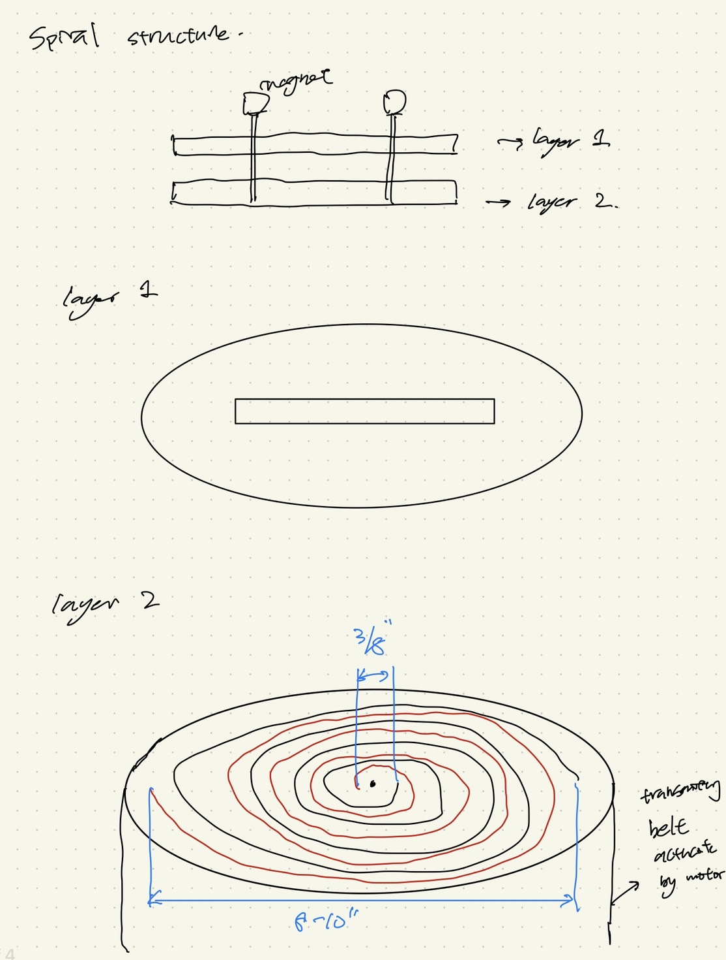

Description:

In this design, we create the two layers for moving the both magnets. The first layer is fixed in the linear direction and the second layer moves the magnet to close each other and apart. There will be ⅜ inches gap which we design.

The major problem is the mechanism work for the one DOF and the speed might not be expected.

## Block diagram:



## Sketch of Initial Design (Solidworks):

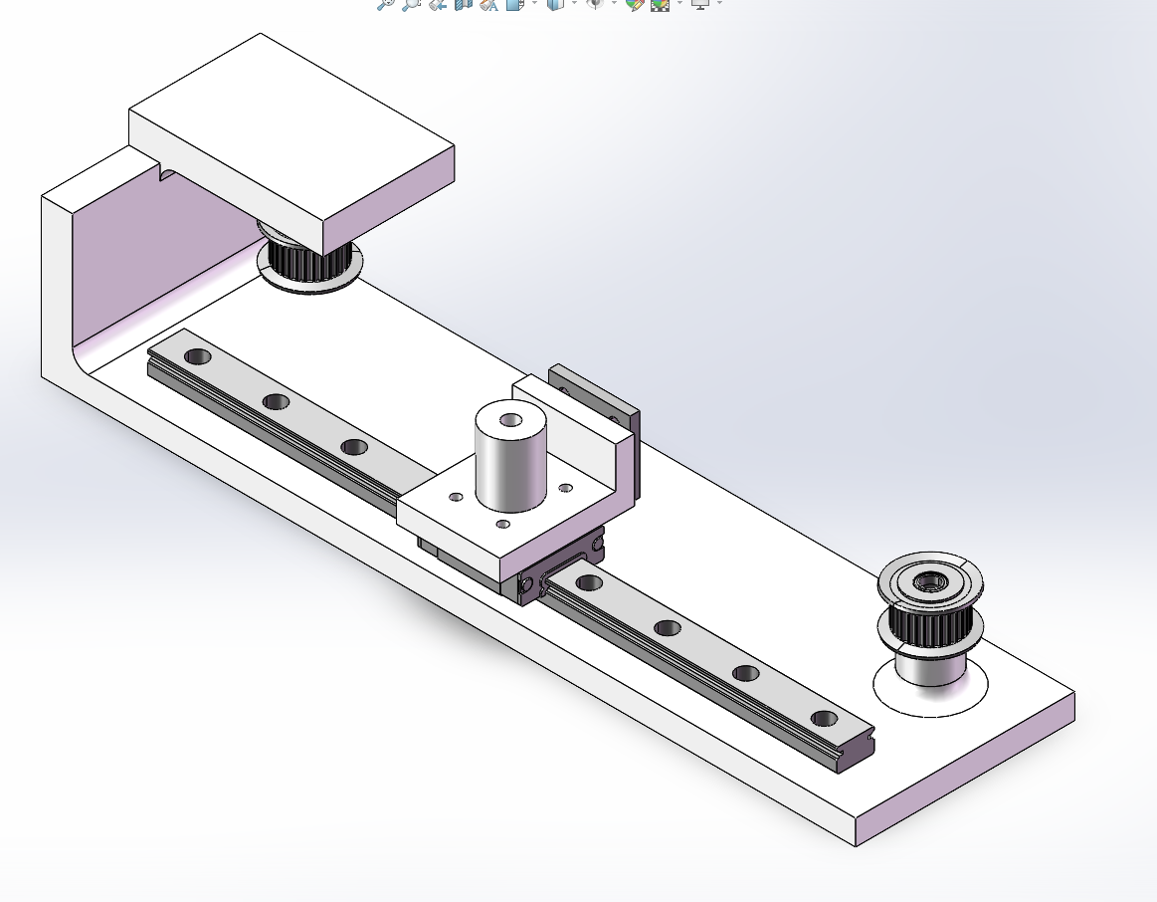

## Description:

This design is to build a prototype of one DOF mechanism and interaction of magnets. We use a linear slider to fix in one axis and transmit with a timing belt. The magnet on the linear slider is an electromagnet with a maximum pull force of 6 lbs. We have decided that in order to best accomplish our design goals, we will use the motion components of the X gantry of a Creality Ender-3, a cheap 3D printer that was readily available to us. This gantry uses rollers that ride in t-slot extrusion, and will save us design work. We will swap the original motor with our own, a brushless dc motor. This will allow us to accomplish the following goals

Goal:

1. Magnet transmission

1.In free motion, the gantry device should be able to match finger speeds up to 150

mm/s or 5.9 in/s.

2.For sensing and actuation the device will have a resolution of 5 microns.

3.The two contact points shall be able to go as close as ⅜” together or 5” apart

1. Magnet Interaction

1.When the user is interacting with a virtual wall, the device will be able to respond with

a stiffness of 1 N/mm or 5.71 lbs/in

2.The device will be able to provide a maximum of 3 lbs of force